HALF Adder:
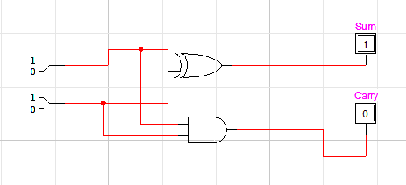
A | B | SUM | CARRY
0 | 0 | 0 | 0
0 | 1 | 1 | 0
1 | 0 | 1 | 0
1 | 1 | 0 | 1

Exercise 1: Full Adder
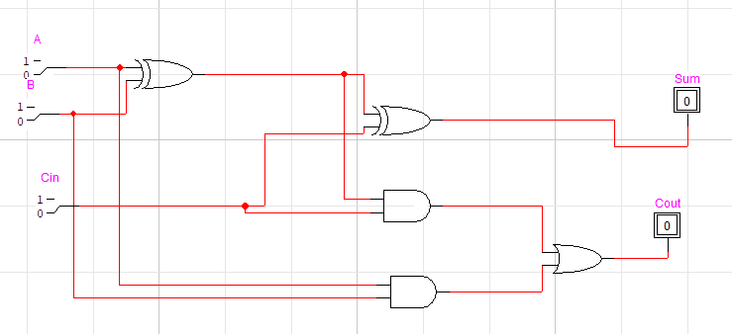

A | B | CIN | SUM | COUT
0 | 0 | 0 | 0 | 0
0 | 0 | 1 | 1 | 0
0 | 1 | 0 | 1 | 0
0 | 1 | 1 | 0 | 1
1 | 0 | 0 | 1 | 0
1 | 0 | 1 | 0 | 1
1 | 1 | 0 | 0 | 1
1 | 1 | 1 | 1 | 1

K-map for the Sum output (S):

\ AB 00 01 11 10
Cin \____________
0 | 0 1 1 0
1 | 1 0 0 1

K-map for the Carry output (Cout):
\ AB 00 01 11 10
Cin \__________________
0 | 0 0 1 0
1 | 0 1 0 1

EXERCISE 2: (FULL ADDER)
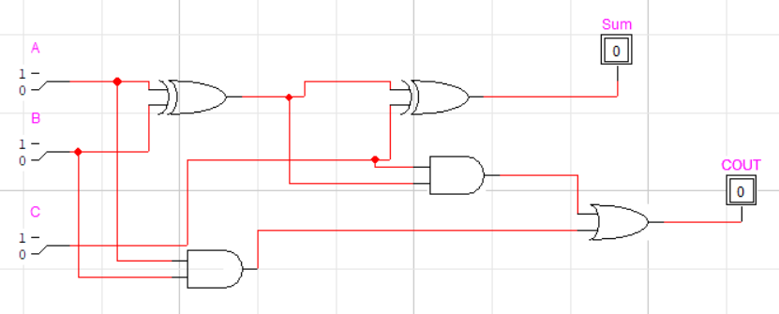

Truth table above.

EXERCISE 3: (Full Subtractor)
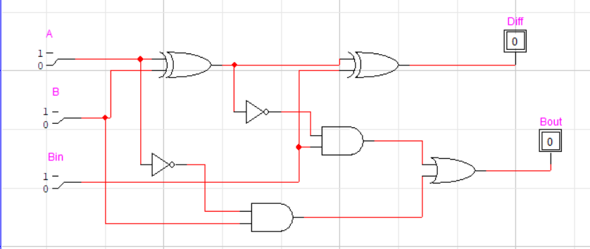
A | B | Bin | Difference | Bout
0 | 0 | 0 | 0 | 0
0 | 0 | 1 | 1 | 1
0 | 1 | 0 | 1 | 1
0 | 1 | 1 | 0 | 1
1 | 0 | 0 | 1 | 0
1 | 0 | 1 | 0 | 0
1 | 1 | 0 | 0 | 0
1 | 1 | 1 | 1 | 1

Boolean:
D = A ⊕ B ⊕ Bin
Bout = (A’.Bin) + (A’.B) + (B.Bin)

